PREMIUM LIST
Belgian Sheepdog Club of America
FRENCH COURSE HERDING TRIAL
CATTLE
Trials open to all AKC Registered and ILP/PAL Dogs of breeds approved by
the AKC for Herding
Dogs must be 9 months or older.
November 1 & 2, 2014
Trial hours: 8:00 AM – completion
To be held outdoors at
T.A.S.K. Farms/Top C Ranch
Leona Valley, CA 93555

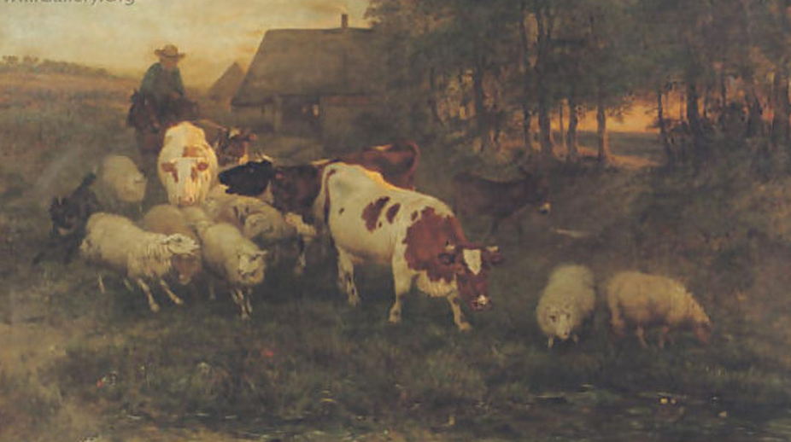

COURSE OFFERED:
French course cattle
Started, Intermediate and Advanced.
ENTRY LIMIT: 20 runs per day
TRIAL SECRETARY
Dorothy DeLisle
1338 Charles Lane
Ramona, CA 92065
760-505-0090
e-mail: gsdvominsel@cox.net

ENTRIES CLOSE October 24, 2014

BELGIAN SHEEPDOG CLUB OF AMERICA OFFICERS
President-------------------------Susan Hoffman
1st Vice-President--------------Sherry Hanley
2nd Vice President–------------Shelly Brosnan
Treasurer–-----------------------Marion Heise
Recording Secretary----------Mary Grace Buckwalter
Corresponding Secretary----Claire Tretheway

HERDING TRIAL COMMITTEE
CHAIRPERSON: Peggy Richter
COMMITTEE:
Bruce Freedman, Penny King, Terry Kenney, Jamie Dixon

JUDGES* *Effective 9/3/2013, AKC issues titles for three (3) qualifying scores under two (2) separate
judges (amended Chapter 4, Section 3 of AKC herding regulations)

Saturday, Nov 1, 2014:
Saturday: AM
Linda Holloway Address: 230 WILDE RD PONCA CITY, OK 74604-6042
Saturday PM
TBD

Sunday Nov 2, 2014:
Sunday AM
Richard Godfrey Address: 4172 BLACK MOUNTAIN RD LA MESA, CA 91941-7905
Home Telephone: (619) 461-0877
Sunday PM
TBD

CLASSES OFFERED -- ALL runs 7 – 10 head cattle (Approximate value $800 each)
Started: Intermediate: Advanced

ENTRY INFORMATION
Make checks/money orders payable in U.S. funds to:
Peggy Richter
Mail, UPS or hand deliver to:
Dorothy DeLisle
1338 Charles Lane
Ramona, CA 92065
760-505-0090
e-mail: gsdvominsel@cox.net
Do not send entries by any method requiring signature for delivery.
All entries must be received at the Trial Secretary’s address no later than:
8:00P.M October 24, 2014 ENTRY FEES: (Includes $3.50 BSCA recording fee
$60.00 per run

$50.00 per run for Exhibition Only
Please note on entry form “Exhibition Only entry”
Exhibition Only entries will be accepted day of trial if space is available

LIMIT: 20 runs per day
Note: Bitches in season shall be eligible and will run in catalog order in trial classes.

VETERINARIAN (on call):
VETERINARIAN (ON CALL)
Animal Emergency Clinic
661-729-1500
1055 West Ave. M., Suite 101, Lancaster, CA 93536

BSCA rules for the FRENCH Course
(http://bsca.info/wp-content/uploads/2013/07/BSCAFrenchcourse.pdf)
In August of 2010, AKC agreed to recognize Parent Club administered Performance events through the issuance of an AKC title certificate and the recording of these titles on AKC pedigrees. BSCA has obtained permission from AKC to establish a herding trial based on the traditional tending skills of our dogs and established a certificate for herding evaluation that duplicates the kind of work for which Belgians were selected. .
The initial AKC approval is for a five year experimental project to allow BSCA to administer French style herding events. If, at the end of the five year period, enough dogs have participated and enough interest has been generated to demonstrate that this is a viable program, AKC will formalize the program.
If AKC approves the program on a permanent basis, those dogs that participated in the experimental phase will have their passing scores and titles recognized.
The French Style course involves tending style with the dog working close to the livestock. Unlike C course, several obstacles and short drives (dog taking stock ahead of the handler) in advance and a gather are required and furrows / boundaries are not. An illustrated description of the course for each level is included

AWARDS
All awards must be picked up the day they're won-none will be held or mailed
Awards to be presented each trial:
A Certificate of Accomplishment will be awarded for all Qualifying Scores
A tile pin will be awarded for all Qualifying Scores
Dog item will be awarded to:
High score in Started
High score in Intermediate
High score in Advanced.

Hand-painted Ceramic 4 x 4 tile will be awarded to:
High score in Started Belgian Sheepdog
High score in Intermediate Belgian Sheepdog
High score in Advanced Belgian Sheepdog

Tile planter will be awarded to:
High in Trial Belgian Sheepdog

Overall High Combined Award to be presented on Sunday:
$50.00 Jeffers gift certificate
Awarded for High Overall Score
(Combined scores for Saturday & Sunday)

INFORMATION FOR EXHIBITORS
RV parking (NO HOOKUPS) and camping is available on a LIMITED basis.
Contact Terry Kenney for reservations:
herdem@aol.com or 661-305-2501
Well-mannered dogs only. No LOOSE dogs. (owners of dogs off lead without specific permission will be asked to leave).
Owners must assume full responsibility.
**SMOKING ALLOWED IN DESIGNATED AREAS ONLY**

LOCAL HOTEL ACCOMODATIONS
E-Z 8 661-273-6400 430 W Palmdale Blvd, Palmdale

DIRECTIONS TO TRIAL SITE 10705 Leona Valley, Leona, CA
DIRECTIONS From FREEWAY 14:
-Take the PALMDALE BLVD EXIT going WEST.
-STAY on this road for approximately 10 miles.
(It will change names to Elizabeth Lake Road.)
-At 90th street there is a STOP SIGN.
(there is a Real Estate Office on one corner & a Feed Store on another)
-TURN LEFT. At the NEXT STREET (Leona Ave)
-TURN RIGHT.
-GO 1 6/10 miles to Giamillo Rd (dirt road)
-TURN RIGHT on Giamillo Rd.
The entrance is the second gate on the right

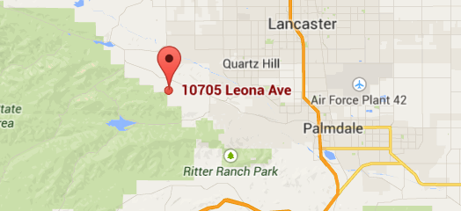

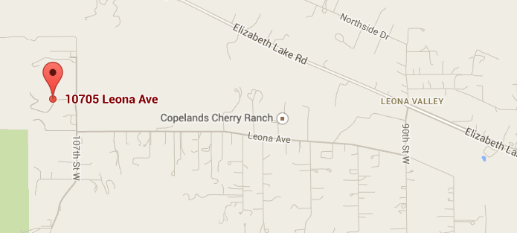
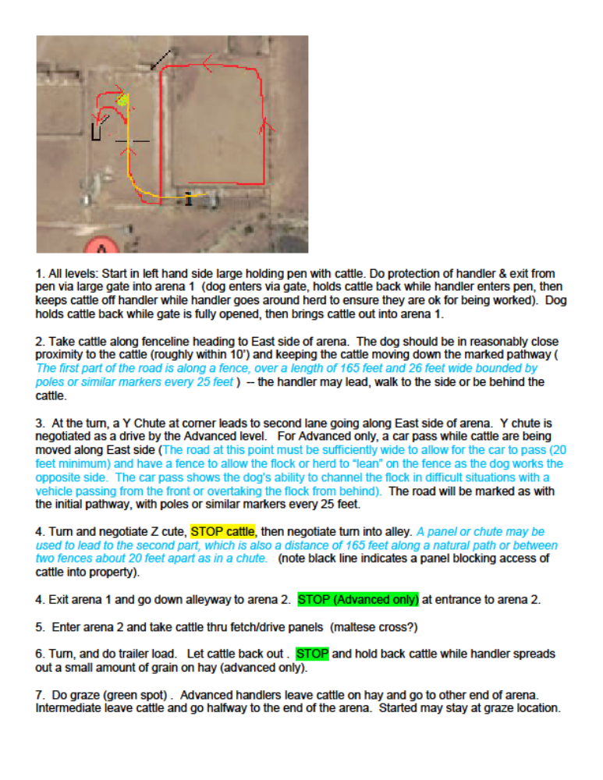

OFFICIAL ENTRY FORM
Belgian Sheepdog Club of America
Event # French-2
TASK FARM 10705 Leona Valley, Leona, CA
Nov 1 & 2 , 2014

Entry fees: $60.00 per entry

Entries close at secretary’s office at 8:00P.M October 24, 2014 or when limit is reached after which time entries cannot be accepted, canceled, or substituted, except as provided for in Chapter 3 Section I of the Regulations for Herding Tests and Trials.

Event Limit:: 50 runs per day (combined)

Checks payable in U.S. funds to: Peggy Richter

Send to: Dorothy DeLisle 1338 Charles Lane

Ramona, CA 92065

760-505-0090

e-mail: gsdvominsel@cox.net

Do not send entries by any method which requires signature for delivery

AM SAT 1 Nov 2014 | PM SAT 1 Nov 2014 | AM Sun 2 Nov 2014 | PM SUN 2 Nov 2014
Started | Started | Started | Started
Intermediate | Intermediate | Intermediate | Intermediate
Advanced | Advanced | Advanced | Advanced

Breed: |  | Variety |  |  | Sex: | Date of Birth: Nov 13
REGISTERED NAMEOF DOG (AKC titles only):

Registration No: |  |  | Call Name
□ AKC No □ AKC Litter No. □ ILP/PAL No: □ FSS# □ Foreign Reg. No. & Country
Breeder:
OWNER
Sire:

Dam:

Actual Owner(s) : PLEASE PRINT

Address, City, State, Zip:

Name of owner’s agent (if any): |  |  |  | Fee enclosed:
I CERTIFY that I am the actual owner of the dog, or that I am the duly authorized agent of the actual owner whose name I have entered above. In consideration of the acceptance of this entry I (we) agree to abide by the Rules and Regulations of the American Kennel Club in effect at the time of this Herding Test or Trial and by any additional rules and regulations appearing in the premium list for this Herding Test or Trial or both, and further agree to be bound by the "Agreement" printed on the reverse side of this entry form. I (we) certify and represent that the dog entered is not a hazard to persons or other dogs. This entry is submitted for acceptance on the foregoing representation and agreement.
SIGNATURE of owner or agent duly authorized to make this entry

PHONE: | E-MAIL

*entry confirmations and judging programs will be sent via e-mail, if available—print clearly
ELIGIBILITY

All dogs nine months of age or older that are registered with the American Kennel Club and classified as Herding Dogs under Chapter 2 of the Dog Show Rules are eligible to participate in herding tests and trials. Dogs classified as Herding Dogs under Chapter 2 of the Dog Show Rules that have been granted an Indefinite Listing Privilege (ILP) or Purebred Alternative Listing (PAL) may participate in tests and trials.

No dog may be entered in two classes on the same course with the same kind of stock under the same judge at any test/trial.

Bitches in season shall be eligible and will run at the end of the class in tests, and in catalog order as listed in the class in trials.
A dog must be entered in the name of the person who actually owned it at the time entries for the herding test or trial closed. If a registered dog has been acquired by a new owner, it must be entered in the name of its new owner in any herding test or Trial for which entries closed after the date of acquisition. regardless of whether the new owner has received the registration certificate indicating that the dog is recorded in his or her name. State on entry form whether transfer application has been mailed to AKC. (for complete rule refer to Chap. 14, Sect 3 of "Rules Applying to Registration and Dog Shows")

AGREEMENT
I (we) acknowledge that the "Rules Applying to Registration and Dog Shows" and the "Rules for Herding Tests and Trials" have been made available to me (us) and that I (we) agree that the club holding this Herding Test or Trial has the right to refuse this entry for cause which the club shall deem to be sufficient. In consideration of the acceptance of this entry and of the holding of the Herding Test or Trial and of the opportunity to have the dog tested or judged and to win prize money, ribbons, or trophies, I (we) agree to hold this club, its' members, directors, governors, officers, agents, superintendents or show secretary and owner or lessor of the premises and any employees of the aforementioned parties harmless from any claim for loss or injury which may be alleged to have been caused directly or indirectly to any person or thing by the act of this dog while in or upon the Herding Test or Trial premises or grounds or near any entrance thereto, and I(we) personally assume all responsibility and liability for any such claim for damage or injury to the dog, whether such loss, disappearance, theft, damage or injury be caused or alleged to be caused by the negligence of the club or any of the parties aforementioned, or by the negligence of any other person, or any other causes.
I (we) hereby assume the sole responsibility for and agree to indemnify and save the aforementioned parties harmless from any and all loss and expense (including legal fees) by reason of the liability imposed by law upon any of the aforementioned parties for damage because of bodily injuries, including death at any time resulting there from, sustained by any person or persons, including myself (ourselves) or on account of damage to property, arising out of or in consequence of my (our) participation in the Herding Test or Trial, howsoever such injuries, death or damage to property may be caused, and whether or not the same may have been caused or may be alleged to have been caused by negligence of the aforementioned parties or any of their employees or agents, or any other persons.
I (we) will pay for any livestock injuries or replacement value in the event of death of any livestock by my (our) dog. In case of any injury to any stock caused by the dog entered, I (we) will assume total responsibility for any damage I (we) agree to pay the full market value of the injured animal in case of serious injury, or the veterinarian bill if the injury is slight.

I (WE) AGREE THAT ANY CAUSE OF ACTION, CONTROVERSY OR CLAIM ARISING OUT OF OR RELATED TO THE ENTRY, EXHIBITION OR ATTENDANCE AT THE EVENT BETWEEN THE AKC AND MYSELF (OURSELVES) OR AS TO THE CONSTRUCTION, INTERPRETATION AND EFFECT OF THIS AGREEMENT SHALL BE SETTLED BY ARBITRATION PURSUANT TO THE APPLICABLE RULES OF THE AMERICAN ARBITARATION ASSOCIATION. HOWEVER, PRIOR TO ARBITRATION ALL APPLICABLE AKC BYLAWS, RULES, REGULATIONS AND PROCEDURES MUST FIRST BE FOLLOWED AS SET FORTH IN THE AKC CHARTER AND BYLAWS, RULES, REGULATIONS, PUBLISHED POLICIES AND GUIDELINES

Single copies of the latest editions of the "Rules Applying to Registration and Dog Shows", the "Obedience Regulations" and the "Regulations for Herding Tests and Trials" may be obtained WITHOUT CHARGE from the AMERICAN KENNEL CLUB, 51 MADISON AVENUE, NEW YORK, NEW YORK 10010

